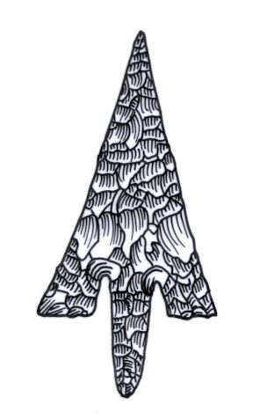
Th ADIAS Occasional Newsletter
February 2005 No. 2 – 2004-2005 Season

Abu Dhabi Islands Archaeological Survey (ADIAS)

Patron: HH Sheikh Mohammed bin Zayed Al Nahyan
P.O. Box 45553, Abu Dhabi, U.A.E.
Tel: +9712 6934515 – Fax: +9712 6810008
Email: adias@erwda.gov.ae
Web: www.adias-uae.com

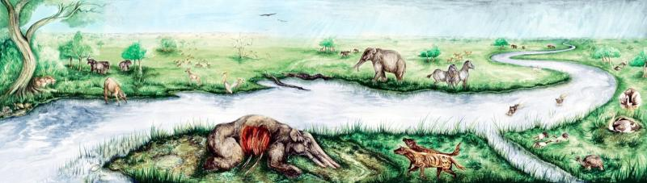Life in Abu Dhabi 6 million years ago - Backdrop of the new Fossil Exhibition
DNA, Flints and Fossils

With the ADIAS 2004-2005 season now well under way, it's time to brief readers of the Occasional Newsletter on some of the work undertaken over the past few months, as well as to outline forthcoming work.
On the 20th December 2004, ADIAS held a press conference together with the Forensic Science Laboratory at Abu Dhabi Police Headquarters. Through DNA analysis, the Forensic Science Laboratory has successfully identified the gender of the oldest man so far discovered in the Emirates. In the first collaboration of its type to have taken place in the UAE, scientists from the Forensic Science Laboratory and archaeologists from ADIAS combined their skills to study the oldest skeleton ever found in the United Arab Emirates. This announcement generated a huge amount of publicity in the local, regional and international press (for more details see below).
The second season of archaeological work at Khor Al Manahil and Kharimat Khor Al Manahil, near Umm az-Zamul, took place from 29th December 2004 until 23rd January 2005. This work was carried out by ADIAS in collaboration with the Department of Antiquities and Tourism in Abu Dhabi's Eastern Region. The team also included a visiting archaeologist from the Department of Museums and Antiquities, Kuwait. ADIAS is pleased to acknowledge the receipt of further sponsorship from Dolphin Energy Ltd to support this work at Khor Al Manahil and Kharimat Khor Al Manahil (for more details see below).
Work on the fossil display is now almost complete, after a series of unavoidable delays. It is hoped that the inauguration of the display will take place within a few weeks (for more details see below).
ADIAS staff have also been busy giving a series of lectures in Abu Dhabi and Dubai (for more details see below).
Two new publications have also been issued with contributions by ADIAS team members (for more details see below).

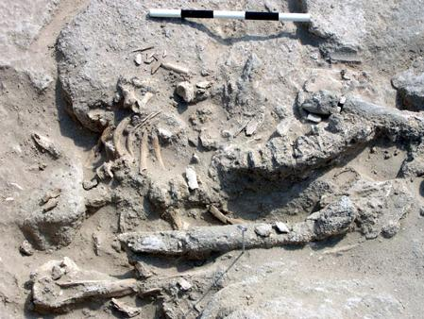Close-up of the skeleton of the oldest human
ever found in the United Arab Emirates
DNA from UAE’s First Man

In the first collaboration of its type to have taken place in the United Arab Emirates, scientists from the Forensic Science Laboratory at Abu Dhabi Police Headquarters and archaeologists from ADIAS have combined their skills to study the oldest skeleton ever found in the UAE.
The skeleton was found during excavations directed by Dr Mark Beech for ADIAS early last year on Abu Dhabi's western island of Marawah. During work at Site MR11, a series of stone buildings were identified, in one of which there was a human skeleton buried on a stone platform.
The skeleton was not well enough preserved, however, for the ADIAS team to determine whether it was of a man or a woman.
Now, thanks to the expertise of the Police Forensic Science Laboratory, the sex of the skeleton has been determined by the recovery of ancient DNA. Deoxyribonucleic acid, DNA, is the chemical at the centre of the cells of living things, which control the structure and purpose of each cell and carries the genetic information during reproduction.
Radiocarbon dating, as well as associated finds, demonstrates that the skeleton dates to around 7500 years ago. This makes the skeleton, and the building in which it was found, the earliest evidence yet found of the presence of Man in the Emirates.
Among parts of the skeleton that were preserved were several teeth, and three of these were examined by Col. Ahmad Hassan Al-Awadi, Director of the Forensic Science Laboratory and his team at the Forensic Pathology Unit. Although the ancient DNA was not well preserved, using the latest forensic science techniques, the Forensic Laboratory was able to determine that the skeleton was a male from its DNA profile.
Preliminary studies suggest that the male individual was between approximately 20-40 years in age. Further research on the skeleton is being continued by the Abu Dhabi Police forensic scientists, while ADIAS plans a further season of archaeological investigations at the site next month.
ADIAS is delighted with the results of this collaboration with the Abu Dhabi Police Forensic Laboratory.
We are particularly grateful to HH Major General Sheikh Saif bin Zayed AI Nahyan, the Minister of Interior, for his support for our work, and look forward to further collaboration with the police on our studies of skeletons from Abu Dhabi's coast and islands.
The ADIAS work on Marawah is carried out in association with the Environmental Research and Wildlife Development Agency, ERWDA, which is responsible for the conservation of Marawah and adjacent islands, as well as the surrounding seas, as part of the Marawah Marine Protected Area.

ADIAS website has record number of visitors

As a direct result of the press conference held to announce the collaboration between ADIAS and the Abu Dhabi Police Forensic Laboratory the ADIAS website had an unprecedented number of visitors on 20th December 2004. A total of 8376 hits were registered on that day, of which 718 represented unique visitors to the website.
This is a new record for the site, whose webmaster is our Senior Resident Archaeologist, Dr. Mark Beech.

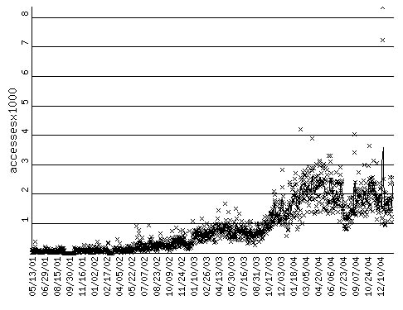

Local press coverage of the Marawah man DNA story fuelled international coverage of the story which appeared in newspapers and news websites worldwide. The story was reported in at least the following twelve countries (and we may have missed several more):
Australia (ABC Online, Advertiser, The Australian, Brisbane Courier Mail, Daily Telegraph, Melbourne Herald Sun, The Mercury, News.com.au & South Australian Advertiser), Bangladesh (The Daily Star), China (People’s Daily Online), Cuba (Granma Internacional Digital), India (Hindustan Times, India Daily & Star of Mysore), New Zealand (New Zealand Herald & Xtra News), Oman (The Times of Oman), Qatar (Gulf Times), Slovenia (Svarog.org), United Kingdom (Asharq Al-Awsat, Reuters UK, The Scotsman, Stonepages.com, Tiscali News & Yahoo News), the USA (CNN and CNN International, Free Internet Press & Reuters USA), and, of course, the United Arab Emirates (including Al Bayan, Gulf News, Gulf Today, Al Ittihad, Al Khaleej, Khaleej Times, UAEInteract.com & Al Watan).
The ADIAS website (www.adias-uae.com) is now one of the most popular websites in the Middle East dealing with the archaeology of the region.
Many thanks to Mark for his hard work on this – finding and excavating archaeological and fossil sites is a key part of our work, but so too is the dissemination of the results, and in today's world, the Internet is one of the most important ways of doing that.
Comments on contents and presentation of the website are always gratefully received.

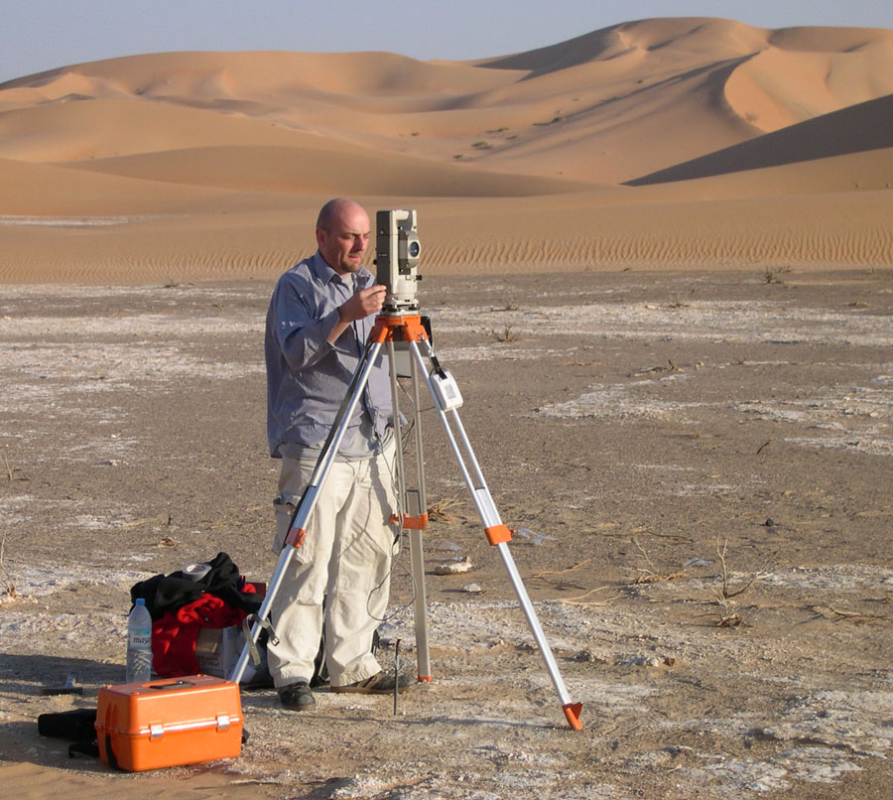
Richard Cuttler surveying at Khor Al Manahil
2nd season at Umm az-Zamul

A first field season at the Umm az-Zamul Neolithic sites, first discovered by staff of the Environmental Research and Wildlife Development Agency, ERWDA, in 2003, took place in January 2004. It was carried out jointly by ADIAS and the Department of Antiquities and Tourism in Abu Dhabi's Eastern Region. The aims of the first season were to evaluate the potential of the archaeological sites. Extensive lithic scatters and a remarkable collection of Neolithic stone tools were recovered, as well as more importantly, for the first time in the interior of the UAE desert, the presence of building structures that are probably contemporary with the Neolithic finds. Such sites are unique in the whole of Eastern Arabia and provide a valuable opportunity to examine life in the desert during the Neolithic period between about 9000 – 6000 years ago.
The second season of work at Khor Al Manahil and Kharimat Khor Al Manahil took place from the 29th December 2004 until the 23rd January 2005. This work was carried out, once again, by ADIAS in collaboration with Department of Antiquities and Tourism. The team comprised Dr Mark Beech (ADIAS Senior Resident Archaeologist), Richard Cuttler (Birmingham Archaeology, University of Birmingham, UK), Dr Heiko Kallweit (Freiburg, Germany), Hamed Al-Mutairi (Department of Museums and Antiquities, Kuwait) and Dr Walid Yasin Al-Tikriti (Department of Antiquities and Tourism, Al Ain). Some field assistance was also provided by Dr Drew Gardner (Zayed University, Abu Dhabi), Marc Dyer and Karen Cooper (Abu Dhabi).
ADIAS is pleased to acknowledge the receipt of further sponsorship from Dolphin Energy Ltd to support this work at Khor Al Manahil and Kharimat Khor Al Manahil.
The aims of the second season were to:
- to map the extent of the archaeological sites at Khor Al Manahil, sites KAM0001 – KAM0021.
- to systematically pick-up and map all lithic material from the Khor Al Manahil sites.
- to make a topographic map of the terrain at Khor Al Manahil so that the archaeological sites could be seen precisely within their landscape context.
- to make a topographic map of the terrain at site KHM0035, the rich lithics scatter first investigated during the 2004 season, so that the archaeological site could be seen precisely within its landscape context.
- to map the extent of the three stone structures, sites KHM0045 – KHM0047, at Kharimat Khor Al Manahil.
- to make a topographic map of the terrain surrounding sites KHM0045 – KHM0047 so that the archaeological sites could be seen precisely within their landscape context.
Detailed mapping was carried out with the aid
of a Nikon C100 Total Station with a data logger using Fast Map FM700 logging software. Local grid coordinates were used from stations which were fixed to national coordinates using a hand-held GPS. The survey comprised a 3D record of the location of each find collected plus a survey of the local topography in order to place the flint within its current topographic location.
This represents some of the most detailed recording ever carried out on Neolithic flint scatters in the Arabian peninsula.
The aims of the second season were all achieved, and twice as much lithic material was collected as during the initial field season. The lithics assemblages from Khor Al Manahil and Kharimat Khor Al Manahil now amount to over 4000 pieces.
Future work will include the databasing, illustration and photographing of this lithic material, so that it can be prepared for full publication. The plan for the 2006 season includes the collection and mapping of remaining lithic scatters as well as the involvement of palaeo-environmental experts. Further investigation of the geology and geomorphology of the region will help to improve our understanding of these sites within their landscape. More importantly, it is planned to undertake optical dating of the dunes overlying some of the Neolithic flint scatters to give an idea of their absolute dating.

New site at Gabat Rukhna

At the invitation of HH Sheikh Mansour bin Zayed Al Nahyan, Minister of Presidential Affairs, an ADIAS team comprised of Peter Hellyer (Executive Director) and Simon Aspinall (Director, Environmental Studies), visited the Gabat Rukhna plantation, near Bida bint Saud, north of Al Ain, in early January, to examine an area where pottery scatters had been reported.
The site proved to be a Late Islamic camping ground, with typical scatters of locally-made and imported pottery, shells, fish-bones and – evidence of more recent occupation - .303 rifle bullets! Several coins had already been collected on the site by members of Sheikh Mansour's staff. While some of these were imported, probably from Iran, and require further study, one, minted during the reign of the mid-19th Century Omani Imam Faisal bin Turki, provided a date for the site.
A provisional assessment of the pottery suggests that the site may have first been used in the late 17th or early 18th Century, then continuing in use until the early to mid 20th Centuries.
Such sites are relatively common in the deserts of Abu Dhabi, many being located in areas where there might have been good grazing after winter rainfall. In such cases, many seem to have been used over a period of at least several centuries.
A more detailed assessment of the random sample of finds collected from the site is planned. ADIAS is grateful to HH Sheikh Mansour bin Zayed for drawing the existence of the Gabat Rukhna site to our attention. The study of such sites can provide useful information on the lifestyle of the people of Abu Dhabi's deserts during the Late Islamic period.
ADIAS Visit to Kuwait

Dr Mark Beech (ADIAS Senior Resident Archaeologist) and Dr Heiko Kallweit (ADIAS associate) visited Kuwait from the 31st January to the 3rd February 2005.
The visit was at the invitation of Shihab Shihab, director of the Department of Museums and Antiquities, part of the National Council for Culture, Arts & Letters in Kuwait.
On 1st February 2005 they both presented lectures to an invited audience at the National Council for Culture, Arts & Letters. The lectures were as follows: “Recent archaeological work on Marawah Island, Abu Dhabi Emirate, United Arab Emirates“ by Dr Mark Beech and “Archaeology in Arabia’s Deserts: Recent fieldwork at Khor Al Manahil, Abu Dhabi Emirate, United Arab Emirates” by Dr Heiko Kallweit.
Following the lectures, they visited a number of newly-discovered archaeological sites in Kuwait, and held meetings to discuss future collaboration and matters of mutual interest.

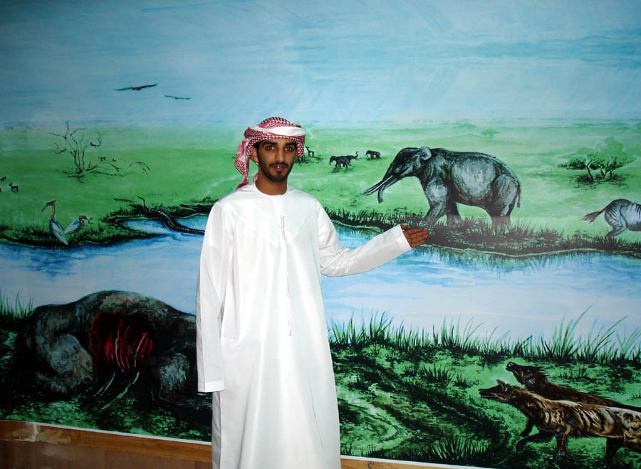An Emirati visitor inspects the backdrop
of the new fossil display

Fossil Display
Work is almost completed on the fossil display case housed in the ERWDA headquarters. The exhibition case is sponsored by ADCO, Takreer and BP, with support from ERWDA and the Private Department of HH the President.
This display will allow members of the public to see for the first time the important Late Miocene fossils discovered in the Western Region of Abu Dhabi emirate. Fossils of the primitive elephant species, Stegotetrabelodon syrticus, on display include the skull, jaws and femur discovered by the late Peter Whybrow at Shuweihat, as well as the 2.54 metre long tusk discovered by ADIAS at Ruwais in November 2002.
The backdrop of the display features a painted reconstruction of how Abu Dhabi looked 6 million years ago. At that time this region was characterised by a savannah grassland environment with plentiful acacia trees and large rivers sweeping through the landscape. The fossils in the display help to form a picture of this landscape and provide important information about the range of animals that once lived in Abu Dhabi.
The display includes an audio-visual component, with two films in Arabic and English about the fossil work. These are “Abu Dhabi – The Missing Link” (30 minutes) and “Hot Fossils from Abu Dhabi” (5 minutes).
It is planned that the inauguration of the display will take place in late February.

Lectures

Over the last few months, ADIAS team members have been active in giving lectures in Abu Dhabi.
On 19th December 2004, Dr Mark Beech, ADIAS Senior Resident Archaeologist, gave a lecture to the Scuba Diving Community in Abu Dhabi. The lecture, co-organised by Kathleen Russell and Hazim Chalabi, was held in the ADMA-OPCO 1st floor auditorium from 8 - 9.30 p.m. Dr Beech presented a lecture entitled "Thoughts on Underwater Archaeology".
On the 6th February 2005, Dr Mark Beech gave a talk about the recent archaeological work carried out on Marawah island to the Dubai branch of the Emirates Natural History Group.
On the 8th February 2005 Dr Mark Beech also lectured to the Science and Literary Forum (SLF) in the Delma Corner within the Cultural Foundation in Abu Dhabi, once again on recent discoveries on Marawah.

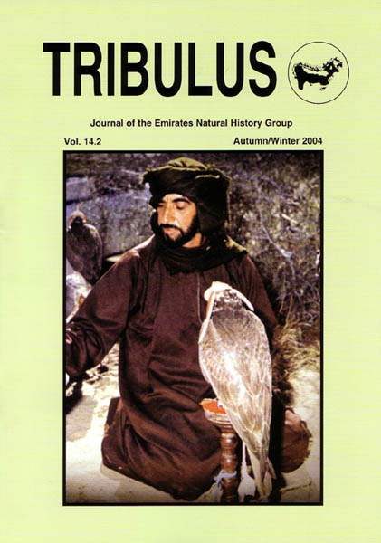
The new issue of Tribulus, vol. 14.2
New Publications

The following publications have been issued locally since the last ADIAS Occasional Newsletter.
The latest issue of Tribulus, the Journal of the Emirates Natural History Group, Vol. 14.2 includes the following articles by ADIAS staff:

Beech, M. and N. Al Shaiba. 2004. Intertidal Archaeology on Marawah Island: New Evidence for Ancient Boat Mooring Sites. Tribulus 14.2: 8-16.
Hellyer, P. and S. Aspinall. 2004. Zayed: Caring Environmentalist. Tribulus 14.2: 3-7.
King, G.R.D. (with ground-plans and elevational drawings by David Connolly). 2004. The Traditional Mosques of Dalma, Abu Dhabi Emirate. Tribulus 14.2: 23-31.
The Emirates Natural History Group, with the sponsorship of the Abu Dhabi Company for Onshore Oil Operations (ADCO) has just published a new book about the geology, archaeology and natural history of Jebel Hafit. This is the first detailed study not only of Jebel Hafit, but of ANY clearly-defined geographical area in the Emirates.

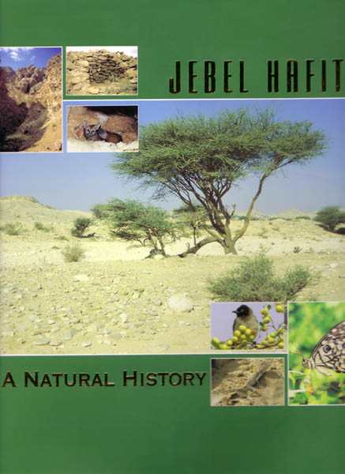
Aspinall, S. and Hellyer, P. (eds.), 2004. Jebel Hafit: A Natural History. Emirates Natural History Group (ENHG). Sponsored by ADCO. ISBN 9948-03-143-1.

The book features chapters by several ADIAS staff and associates: "Geology" by Tony Kirkham (pages 15-35), "Archaeology" by Dr. Rob Carter and Dr. Walid Yasin Al-Tikriti (pages 48-64), "Troglobites" by Dr. Mark Beech, Olivia Pozzan and Simon Aspinall (pages 147-8), and "Birds" by Simon Aspinall (pages 187-220).
Copies are available from the ADIAS office at Dh 100 each.

Forthcoming Publication

On 21st February, the Department of Environmental Research (DER), of the Emirates Heritage Club, formerly known as the Commission for Environmental Research (CER), will release a new publication, the Abu Dhabi Marine Atlas. Chapters by ADIAS staff include: “Archaeology of Abu Dhabi's Coastal Zone” by Peter Hellyer, “Birds” by Simon Aspinall, and “Fishes” by Dr. Mark Beech.
--------------------------------------------
The ADIAS Occasional Newsletter is
edited by Dr. Mark Beech & Peter Hellyer.
----------------------------------------

