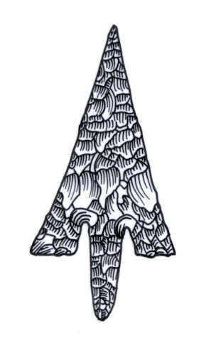
Th ADIAS Occasional Newsletter
May 2004 No. 4 – 2003-2004 Season

Abu Dhabi Islands Archaeological Survey (ADIAS),

Patron: HH Sheikh Mohammed bin Zayed Al Nahyan
P.O. Box 45553, Abu Dhabi, U.A.E.
Tel: +9712 6934515 – Fax: +9712 6810008
Email: adias@erwda.gov.ae
Web: www.adias-uae.com

More work on 7000 year old settlement
on Marawah Island

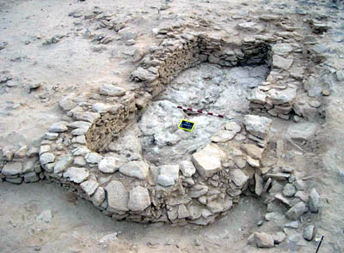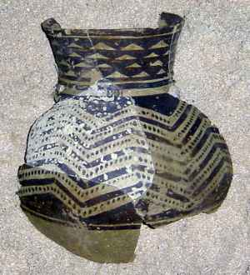
View of Room 1 at MR11 Pottery vessel from MR11

The highlight of the recently-completed ADIAS season was further work at the 7000 year-old village on Marawah. This has the best-preserved and most sophisticated buildings of Neolithic date that have so far been discovered anywhere in Eastern Arabia. The significance of the site, allocated the site code MR-11, was first recognised last year. Among finds this spring were a human skeleton, the earliest inhabitant of Abu Dhabi so far discovered, as well as the most complete Neolithic pottery vessel ever found in the UAE (above right).
The MR11 season lasted from 3rd March to 3rd April. Excavations were directed by Dr Mark Beech (our ADIAS Senior Resident Archaeologist), with other team members including John Martin, a veteran of many ADIAS campaigns, and Richard Cuttler and Derek Moscrop from Birmingham Archaeology Unit. Dr Heiko Kallweit (University of Freiburg, Germany) joined us to study the lithic (stone tool) finds.
The aims of this second season were to undertake detailed mapping and to continue excavations on a building complex in Area A.

THE BUILDING STRUCTURE

The building has proved to be a very interesting multi-phase building dating to the Neolithic period. Two radiocarbon dates from the site suggest that the site was in use at least 6500 to 7000 years ago (see the January 2004 newsletter for details).
After removing many large stone slabs and rubble, representing collapse from the original walls, the shape of part of the structure was defined. Area A is a large building built in at least three phases. So far, only one room, Room 1, has been excavated. This is about 4.6 metres long and 1.8 metres wide, oriented NE-SW. The northern end had an outwards-projecting apsidal wall with three doorways through the east, west and southern walls. A room of similar size and shape was located to the south, with traces of two further rooms to the east. The room to the south appears to be the earliest part of the building so far identified, as the walls of Room 1 were clearly bonded onto it (see photograph opposite). The walls of the rooms to the east of Room 1 were bonded onto its eastern wall, suggesting that they were built later (see photograph below).

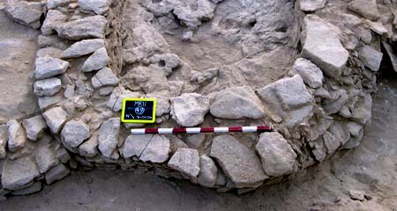Detail of wall 49, the northern end of Room 1

The walls were well built and constructed using a double-skin method, large stones first being placed as inner and outer layers, and smaller stones then being used to fill the cavity. This method had not previously been identified on sites of this date in SE Arabia.

THE SKELETON

After the 2003 season, we thought that the structure had a purely domestic function, as finds included a range of typical artefacts and food debris (see below). We were rather surprised, therefore, to find that the room had also been used as a burial chamber. A series of large stone slabs had been placed across the southern end of the room, immediately against the wall by the southern doorway. A human burial had been placed on top of these slabs. It seems likely that this burial was secondary to the original use, and occurred after the room had been abandoned, since anyone entering from the room to the south would have trod on it.

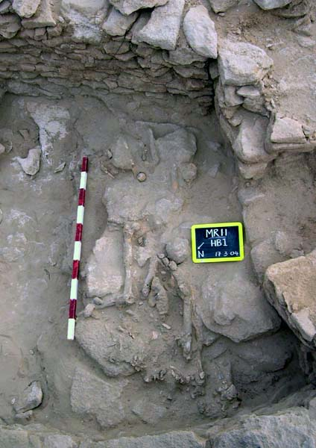
The skeleton found on the stone platform
at the southern end of Room 1

The skeleton was of an adult (of as yet undetermined sex) and may have originally been in a highly flexed position turned slightly on its left side, with its head facing NE. Unfortunately most of the bones were poorly preserved, probably as a result of post-burial disturbance and the collapse of the walls and roof. All that remained of the skull were a few fragments and some loose teeth, located close to the SW corner of the room. The trunk was represented by a number of vertebrae, some ribs, a sacrum fragment and both pelves, all of which appeared to be largely in-situ. There were also fragments of the arms. Most of the left femur remained, and part of the right tibia. The position of these suggested that either the legs had been bent in a highly flexed position, or that the legs had been bundled post-mortem with the rest of the body. Clearly the burial has been disturbed, with the right femur being found towards the SE corner of the room. The feet from this individual were found some two and a half metres away in the northern half of the room! One of the feet was found next to a cluster of pottery sherds which turned out to be the greater part of the pottery vessel (see below). The conjoining pottery fragments were found distributed across the room, perhaps indicating that there has been some linear pattern of disturbance across the room.

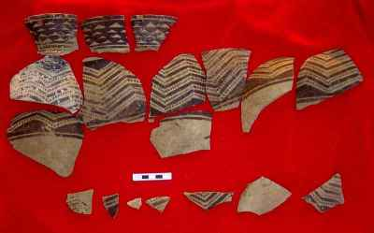
Potsherds from Room 1, prior to
the vessel being reconstructed

THE POT

The most spectacular of the finds recovered from Room 1 was an almost complete pottery vessel with an intricate painted design on its exterior. As far as we can tell, this is the earliest, most complete, pottery vessel ever found in the UAE (photograph on newsletter cover). The usual type of pottery found on sites of this period is known as “Ubaid” ware, after the site of Tell Al-Ubaid in southern Iraq. It is generally characterised by its hard pale greenish fabric and by painted decoration in the form of black geometric lines and chevrons on its exterior. Whilst the fabric and painted components are clearly “Ubaid” in tradition, this vessel, however, does not match previous Ubaid material found in the UAE or elsewhere in the Arabian Gulf.
This shape of vessel, as well as the decoration of chevrons, dotted lines and inverted triangles, has not been previously found in Eastern Arabia and appear to have parallels with sites in western Iran dating the early 5th millennium BC. It may be an import from the Susiana/Deh Luran plain area. Prof. Ernie Haerinck (Univ. of Ghent, Belgium) and Prof. Dan Potts (Univ. of Sydney, Australia) have kindly provided us with some provisional comments on the MR11 pottery vessel.

PLASTER VESSELS
A large number of fragments of plaster vessels were also found in Room 1. Most were plain, although some had traces of pinkish-red and dark grey paint on the outside of them (see photograph below). Some were clearly pieces of quite large vessels with walls almost 1cm in thickness. There were also some very fine fragments of plaster vessels, which were only about 4mm in thickness.
In the whole of the Lower Gulf, apart from Marawah, such plaster vessels are only known from ADIAS excavations at the Ubaid period settlement on Dalma island. Some of the fragments from Dalma have been analysed at the British Museum, showing that most were manufactured from local gypsum, although some were made of lime plaster.

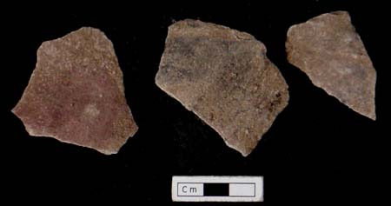
Painted plaster vessel fragments

The tradition of using plaster is known from the early Neolithic period in the Levant and Mesopotamia and the idea of making such vessels in the UAE may have originated from the import of Ubaid-period vessels from Mesopotamia, since the patterns on some of the plaster vessel fragments seem to emulate the designs on the pottery.
LITHICS (Stone tools)

A small quantity of lithic tools was recovered during the excavation. These included a number of flint projectile points (see photograph below) as well as a “tile knife” made from grey tabular flint. These are currently being studied by Dr Heiko Kallweit.
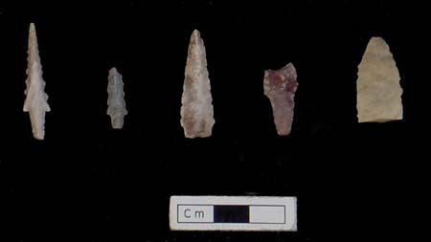
Selection of flint projectile points

OTHER FINDS

All the sediment removed during the excavation was dry sieved to recover objects that could be missed during excavation. Over a hundred beads were recovered.

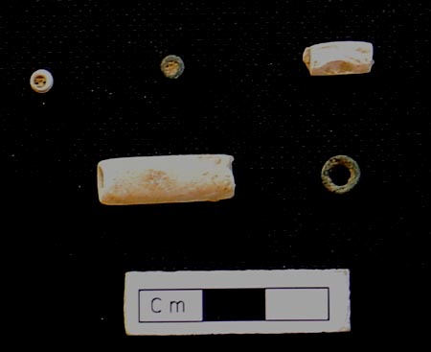
A selection of beads

The beads have been catalogued, measured and databased by Karen Cooper, our ADIAS Administrative Assistant. They were generally made from shell, although there were a few which may be of coral, and several of stone. Most were extremely small, just a few millimetres in size, although there were also a few larger tubular beads (see photograph above). These beads are similar to those found on other broadly contemporary sites in the UAE, as on Dalma and at Jebel Buhais in Sharjah.

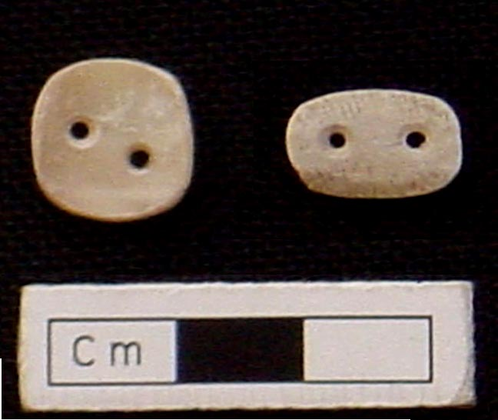
Pearl oyster buttons

Two buttons made from pearl oyster shell were amongst the most delicate and beautiful finds (see photograph above).
The remains of food consumed by the inhabitants included bone fragments from sheep or goat, dugong, marine turtle, as well as various types of fish including requiem shark, grouper, emperor and seabream. Shellfish were also collected and these included predominantly pearl oyster, Pinctada spp., the gastropod species, Lunella coronata, and bivalves like Barbatia spp.
More excavations are planned in March 2005.
The preliminary results of this season’s work were presented at the 2nd Symposium on Recent Archaeological work in the United Arab Emirates, held in Al Ain from 7-8 April 2004 (see later in this newsletter for more details), while further details will be presented at the Seminar for Arabian Studies at the British Museum from 22-24 July, 2004. For more details visit the following website: www.arabianseminar.org.uk

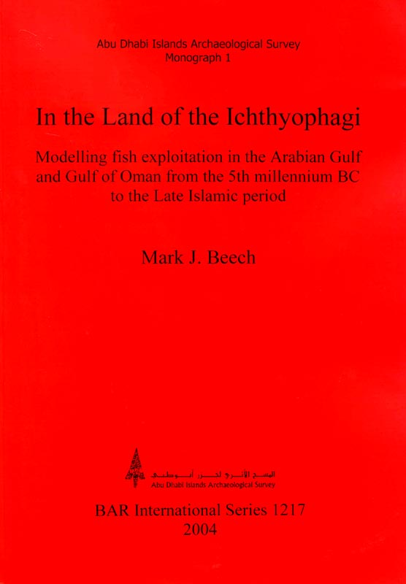
New ADIAS book published
ADIAS is pleased to announce the publication of its latest book. Written by ADIAS Senior Resident Archaeologist, Dr Mark Beech, the book is entitled: “In the Land of the Ichthyophagi: Modelling fish exploitation in the Arabian Gulf and Gulf of Oman from the 5th millennium BC to the Late Islamic period.” The book is published in the British Archaeological Reports International Series, (Volume S1217. ISBN 1841715778). and can be ordered from ArchaeoPress, Gordon House, 276 Banbury Road, Oxford OX2 7ED, U.K. tel/fax: +44 (0)1865 311914. email: bar@archaeopress.com – website: www.archaeopress.com and is priced 39 UK pounds. It can be also purchased online via www.oxbowbooks.com, while we hope to obtain copies for sale through the ADIAS office.
This book is the result of four years of research by Mark for his PhD (awarded in 2001) in the Departments of Archaeology and Biology at the University of York in the U.K. The principal data forming the basis for the study are 23 archaeological fish bone assemblages from sites located throughout the Arabian Gulf/Gulf of Oman, including several sites discovered by ADIAS in Abu Dhabi’s Western Region. The chronological focus is from the 5th millennium BC to the Late Islamic period. This research provides for the first time a detailed insight into the status of past fisheries resources in the region as well as an insight into the fishing strategies used by the early coastal inhabitants of the Gulf during the past 7000 years.
The book is the first in a planned series of Abu Dhabi Islands Archaeological Survey Monographs, and considers the interactions between the goals of coastal societies, their fishing strategies and environment, thereby addressing some key questions of relevance to the archaeology of south-east Arabia.
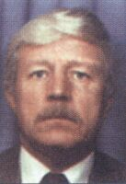 
Prof. Graham Evans Dr. Tony Kirkham

Sabkha Workshop

ADIAS, in collaboration with the Environmental Research and Wildlife Development Agency (ERWDA), organised on 14 March a half day workshop on the Abu Dhabi Sabkha. A slide, overhead and video presentation was made by Professor Graham Evans and Dr. Tony Kirkham. The meeting was attended by staff from ADIAS and from several ERWDA departments. Further details are provided on our website at:
www.adias-uae.com/sabkha.html.



2nd Archaeology Symposium

A 2nd Symposium on Recent Archaeological work in the United Arab Emirates was held from 7-8 April 2004 at the Mercure Hotel Grand Jebel Hafeet in Al Ain. The symposium was organised by the Zayed Centre for Heritage and History and ADIAS Executive Director Peter Hellyer, under the patronage of HH Sheikh Sultan bin Zayed Al Nahyan.
The Symposium included the following papers by ADIAS staff and associates:
Dr. Heiko Kallweit, Dr Mark Beech (ADIAS Senior Resident Archaeologist) and Dr Walid Yasin Al-Tikriti (Department of Antiquities and Tourism, Al Ain) presented a paper entitled: “Neolithic occupation in the southeastern region of the United Arab Emirates”.
Dr. Mark Beech, (ADIAS), Richard Cuttler and Derek Moscrop (Birmingham University), Dr. Heiko Kallweit (ADIAS & Freiburg) and John Martin (ADIAS), presented a paper entitled:
“New results from excavations of a Neolithic settlement on Marawah island, Abu Dhabi, United Arab Emirates”
Dr. Geoffrey King (Department of Art and Archaeology, School of Oriental and African Studies, SOAS, University of London and ADIAS Academic Director) presented a paper entitled: “Mosques of the Islands of Abu Dhabi”.
Dr King is currently preparing a book for ADIAS on Mosques in Abu Dhabi, which is due to be completed later this year.
ADIAS Associates, Dr. Michele Ziolkowski and Sheikh Abdullah bin Suhail al-Sharqi, presented a paper entitled: “Fujairah Fort and its Associated Settlement.”
It is planned that the papers from this symposium will be published by the Zayed Centre for Heritage and History.

Visit to Kuwait

ADIAS Senior Resident Archaeologist, Dr Mark Beech, and ADIAS associate, Dr Heiko Kallweit, were invited to give lectures to the Department of Antiquity and Museums in Kuwait on 20 April 2004. This department is part of the Kuwait National Museum and the National Council for Culture, Arts and Letters. They presented lectures on the recent work carried out by ADIAS on Miocene fossils, Neolithic desert settlements, and the Neolithic settlement on Marawah island.
Mark and Heiko also accompanied Sultan Al-Duwish and Mohammed Al-Ghanem on a tour of sites recently discovered by the Kuwait Department, mainly along the north coast of Kuwait Bay. They also met Shehab Shehab, Director of the Department of Antiquity and Museums in Kuwait, to discuss future collaboration and projects. A Kuwaiti colleague may now join our team working in association with the Al Ain Department of Antiquities and Tourism on Neolithic settlement sites in the SE deserts of Abu Dhabi in January next year.
Mark also met with Dr Sulaiman Almatar (Department Manager of the Mariculture & Fisheries Dept. in the Kuwait Institute for Scientific Research, KISR) and Dr Mohsen Al-Husaini (Head of the Fish Ageing Laboratory, Mariculture & Fisheries Dept., KISR) to discuss current projects and work being undertaken by Mark and Dr. Al-Husaini on marine catfish (Ariidae) otoliths from the Neolithic settlement of H3, Sabiyah, Kuwait.

Oman conference

Dr Mark Beech participated in the International Conference, "Magan, an Early Arabian Civilization and the first Maritime Trade between India and the Near East", organised by the Ministry of National Heritage & Culture of Oman between 24th-27th April. The programme included a two-day excursion to the main prehistoric sites explored by the Italian/French Joint Hadd Archaeological Project along the coastline between the towns of Quryat and Suwaih. One of the results of the conference was the announcement of the launch of a new journal called MAGAN, to be published by the Ministry. This will publish all work related to the archaeology of ancient Magan, which includes both Oman and the UAE. The first issue of the journal will contain the papers from the conference.

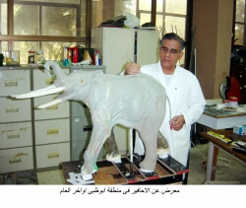
Fossil Display
Work on the display of Late Miocene fossils is continuing. Casting of the scale model of the Late Miocene elephant, Stegotetrabelodon syrticus, is taking place within the next few days while construction of the display case should be completed by the end of the summer. The display will be housed in the ERWDA headquarters, and is being sponsored by ADCO, Takreer and BP. It is hoped to inaugurate the display in October.

Help on other Exhibitions

ADIAS has also been asked in recent months to provide advice and assistance for two other small displays in Abu Dhabi.
One will be in the Grand Arch of the new Emirates Palace Hotel, near ADNOC, which is scheduled to be opened in time for the GCC summit conference in December.
ADIAS Executive Director Peter Hellyer has been working with the Hotel’s Executive Committee and with a firm of British designers to determine some of the content for the display, which will include fossils, replicas of Neolithic tools (being specially made by our flint expert, Dr. Heiko Kallweit), and Bronze Age and Iron Age pottery.
In association with ERWDA, advice is also being given to the Museum and Military History Department of the Armed Forces on the content of a small display that is being planned for the recently-rebuilt Customs House at the Maqta Bridge.

Coastal Survey

In April, Simon Aspinall and Peter Hellyer carried out a rapid survey of the route of a new pipeline from Ruwais to Umm al-Nar, as part of a review of pipelines and other installations belong to TAKREER. While much of the route, particularly at the eastern end, crossed areas of sabkha, which are known to be of little interest in terms of archaeology and fossils, the western sector of the line, from near Mirfa to Ruwais, crosses areas that are more interesting. In particular, there are a number of small hills and outcrops that are of Late Miocene date.
One archaeological site of interest was identified on an aeolianite (fossil sand dune) outcrop, on which there was an extensive scatter of flint flakes and debitage. Our ADIAS flint expert, Heiko Kallweit, has now examined the pieces collected from this site, and has discovered that the flakes all seem to have come from the same original piece of material, showing that flint working occurred at the site on at least one occasion.
Several fossil sites dating to the Late Miocene period, 6-8 million years ago, were also found, some of which contained a wide range of material, including fossils of fish, crocodile, turtle, molluscs and mammals. Further examination of some of these sites is planned. The identification of these sites provides us with a better understanding of the extent of the Late Miocene fossil-bearing sites of the Western Region.
Several of the sites lie in the onshore section of the Marawah Marine Protected Area, MMPA, and details of these will be included in the Protected Area database.

Lectures

Over the last few months, ADIAS team members have been active in giving lectures in Abu Dhabi.
Peter Hellyer, our Executive Director, has spoken twice to the Zayed Private Academy for Girls, on an outline on the archaeology of Abu Dhabi and on the history of the emirate, including its tribes, and is now collaborating with a school project on collecting oral data on tribal history. Interesting data that has not previously been published, (in English, at least!), has already been collected on traditions of the origins of the Bani Yas.
Peter also spoke on the history of Abu Dhabi and its tribes to students at Zayed University in Abu Dhabi.
On 15th June, Mark Beech will talk about the Marawah excavation season to the Emirates Natural History Group. The lecture will be held in the 1st floor auditorium of the Cultural Foundation in Abu Dhabi starting at 8 p.m. All are welcome.

Forthcoming Papers

Two papers on ADIAS work are due to be published shortly in Abu Dhabi-based journals.
The next issue of LIWA magazine, published in Arabic by the Centre for Documentation and Research and due in early July, will include a paper by Peter Hellyer on the Late Islamic fortress at Mantiqa al-Sirra, east of Medinat Zayed.
The next issue of TRIBULUS, the bi-annual journal of the Emirates Natural History Group, will include a paper by Dr. Geoffrey King, ADIAS Academic Director, on the Muraykhi merchant’s house on Dalma, one of the UAE’s most important surviving domestic buildings.
Copies of TRIBULUS will be available from the ADIAS office.

-------------------------------------------
The ADIAS Occasional Newsletter is
edited by Dr. Mark Beech & Peter Hellyer.
---------------------------------------

