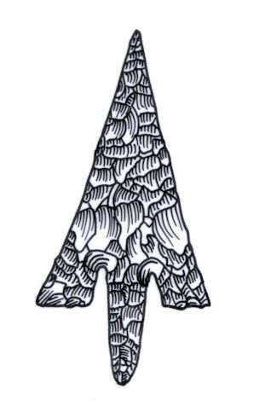
Th ADIAS Occasional Newsletter
November 2004 No. 1 – 2004-2005 Season

Abu Dhabi Islands Archaeological Survey (ADIAS)

Patron: HH Sheikh Mohammed bin Zayed Al Nahyan
P.O. Box 45553, Abu Dhabi, U.A.E.
Tel: +9712 6934515 – Fax: +9712 6810008
Email: adias@erwda.gov.ae
Web: www.adias-uae.com

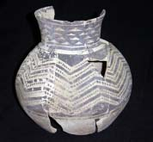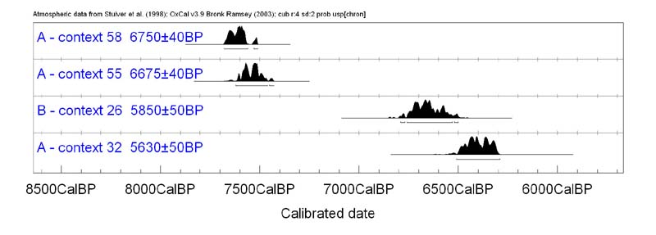
ADIAS new season underway - Interesting news
about radiocarbon dating of Marawah settlement

With the ADIAS 2004-2005 season now well under way, it's time to brief readers of the Occasional Newsletter on our plans for the next few months, and to report on the work undertaken since the summer break.
The initial focus over the last few weeks has been on the preparation of papers for publication relating to the work carried out earlier this year at Kharimat Khor al-Manahil, near Umm az-Zamul, and on Marawah. Two papers have recently been submitted for publication to the Proceedings of the Seminar for Arabian Studies (for more details see below).
Dr Geoffrey King (ADIAS Academic director) arrived in Abu Dhabi for a short visit in late October to work on a new book to be published by ADIAS next year entitled “The Mosques of Abu Dhabi” (for more details see below).
Research is also under way by ADIAS staff for a forthcoming book on “Shells and Archaeology” (see below for more details).
This winter will see the launch of the exhibition of Late Miocene fossils from Abu Dhabi. The exhibition is sponsored by ADCO, Takreer, BP and the Environmental Research and Wildlife Development Agency (ERWDA).
Work is also proceeding on the analysis of mammal and fish bone assemblages recovered from excavations of two important Neolithic sites in the Gulf, Dalma island in the UAE, and site H3 in Kuwait.
Planning is now being finalised for an extensive programme of further fieldwork early in the New Year, which will focus on continued investigations of important Neolithic structures and associated lithic scatters located deep in the south-east desert
of Abu Dhabi, near Umm az-Zamul. This work is being carried out in collaboration with the Department of Antiquities and Tourism in Abu Dhabi's Eastern Region.
Here, as elsewhere, we will be working in close collaboration with the Environmental Research and Wildlife Development Agency, ERWDA, with results being incorporated into the Abu Dhabi Environmental Database. All of this work, of course, involves extensive expenditure, and we are pleased to acknowledge the receipt of further sponsorship from Dolphin supporting this work at Kharimat Khor al-Manahil, and of support from BP for some of our coastal geological studies (see below).
Oldest archaeological
site in the UAE

ADIAS has recently received some exciting news. Two charcoal samples from the initial occupation horizon at site MR11 on Marawah island have been successfully radiocarbon dated to around 7600 years BP (see picture on previous page). This makes the site the oldest confirmed archaeological site in the United Arab Emirates.
The samples were AMS radiocarbon dated by the Scottish Universities Environmental Research Centre at Glasgow University.
The MR11 site is not only the earliest known site in the United Arab Emirates, it also has the best-preserved and most sophisticated buildings of Neolithic date that have so far been discovered anywhere in Eastern Arabia (see ADIAS May 2004 Occasional Newsletter). Among finds discovered this spring at the site were a human skeleton, the earliest inhabitant of Abu Dhabi so far discovered (see story below), as well as the most complete Neolithic pottery vessel ever found in the UAE (see photo above).

Abu Dhabi Police help
identify UAE’s oldest man
In the first collaboration of its type to have taken place in the United Arab Emirates, scientists from the Forensic Science Laboratory at Abu Dhabi Police Headquarters and archaeologists from the Abu Dhabi Islands Archaeological Survey, ADIAS, have combined their skills to study the oldest skeleton ever found in the United Arab Emirates.
The skeleton was found during excavations directed by Dr Mark Beech earlier this year on Abu Dhabi's western island of Marawah. During work at Site MR-11, a series of stone buildings were identified. In one of them, there was a human skeleton buried on a stone platform.
The skeleton was not well enough preserved, however, for the ADIAS team to determine whether it was of a man or a woman.


DNA double helix

Now, thanks to the expertise of the Forensic Science Laboratory of the Abu Dhabi Police Headquarters, the sex of the skeleton has been determined by the recovery of ancient DNA. Deoxyribonucleic acid, DNA, is the chemical at the centre of the cells of living things, which control the structure and purpose of each cell and carries the genetic information during reproduction. Radiocarbon dating, as well as associated finds, demonstrates that the skeleton dates to around 7600 years ago. This makes the skeleton, and the building in which it was found, the earliest evidence yet found of the presence of Man in the Emirates.
Among parts of the skeleton that were preserved were several teeth, and three of these have now been examined by Lt. Col. Ahmad Hassan Al-Awadi, Director of the Forensic Science Laboratory and the Forensic Pathology Unit at Abu Dhabi Police Headquarters. Although the ancient DNA was not well preserved, using the latest forensic science techniques, the Forensic Laboratory was able to determine that the skeleton was a male from its DNA profile.
Preliminary studies suggest that the male individual was between approximately 20-40 years in age. Further research on the skeleton is being continued by the Abu Dhabi Police forensic scientists, while ADIAS plans a further season of archaeological excavations at the site in March-April next year.
We are delighted with the results of this collaboration with the Abu Dhabi Police Forensic Laboratory. The expertise of the police forensic scientists has provided valuable new information about the oldest human being ever discovered in the UAE. We are grateful to HH Major General Sheikh Saif bin Zayed Al Nahyan, Under Secretary of the Ministry of Interior, for his support for our work and we look forward to further collaboration with the police on our studies of ancient skeletons from Abu Dhabi's coast and islands.
The ADIAS work on Marawah is carried out in association with the Environmental Research and Wildlife Development Agency, ERWDA, which is responsible for the conservation of Marawah and adjacent islands, as well as the surrounding seas, as part of the Marawah Marine Protected Area.
More information about the recent work carried out by ADIAS can be found on the following web pages:
www.adias-uae.com/marawah.html
www.adias-uae.com/mr11.html

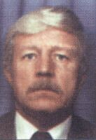 
Prof. Graham Evans Dr. Tony Kirkham

Sabkha experts
visit Abu Dhabi

ADIAS associates Professor Graham Evans and Dr. Tony Kirkham recently visited Abu Dhabi to attend the 11th ADIPEC, Abu Dhabi International Petroleum Exhibition and Conference, which took place at the International Exhibition Centre in Abu Dhabi from 12-14 October 2004.
The event included an international conference on “Evaporite stratigraphy, structure and geochemistry and their role in hydrocarbon exploration and exploitation”.
One session at the conference, entitled “Abu Dhabi Evaporite Retrospective” saw Prof. Graham Evans gave a presentation on the contribution of Dr Douglas Sherman to Evaporite studies. Evans also presented a paper entitled “Arabian Tales: a historical review of the Quaternary sedimentology of the Arabian Gulf and its geological impact”. Dr. Tony Kirkham presented a paper entitled “Chloride and Sulphate Deposits, Abu Dhabi Coastal Regions”.
During their stay in Abu Dhabi they also made fieldwork trips to Tarif and to the island of Al-Aryam and completed reports on the geology of the islands of al-Aryam and Balghelam. We are grateful to HH Sheikh Hamdan bin Zayed, Deputy Prime Minister, Minister of State for Foreign Affairs and the Deputy Chairman of ERWDA, for permitting access to Al-Aryam.

BP helps studies
of UAE heritage
International oil company BP has once again provided support for our studies of the geology and archaeology of the coastal zone.
The help is in the form of assistance for research into two distinct aspects of Abu Dhabi's heritage - research into the geology of the island of Balghelam, north-east of Abu Dhabi, and a study of Neolithic (Late Stone Age) flint tools from the western island of Dalma.
Archaeological excavations on Balghelam, carried out with the permission of the island's owner, Presidential Court Chamberlain HE Sheikh Surour bin Mohammed Al Nahyan, have shown that the island was occupied as much as four thousand years ago, perhaps by traders passing down the Gulf from Bahrain. Balghelam is close inshore, but, like many of Abu Dhabi's islands, is divided from the mainland by a shallow channel.
Earlier this year, Prof. Graham Evans and Dr Tony Kirkham undertook research for ADIAS collecting rock samples from the island, which are now to be dated at Britain's Southampton University. This will help us to date the evolution of the shorelines of the islands and of nearby coastal areas of Abu Dhabi over the past few thousand years, adding valuable data to knowledge of the pattern of human settlement in the area. The results from the analysis of the rock samples will be included in a publication being prepared by ADIAS on the archaeology of Balghelam.
Other excavations by ADIAS on the western island of Dalma have identified one of the earliest human settlements known in the United Arab Emirates. It was occupied between 6500-7500 years ago, or the Neolithic period.
The inhabitants of the Dalma site were trading by sea with Mesopotamia (present-day Iraq), and depended for their food on shellfish, fish, turtles and dugongs, as well as on domestic animals like sheep and goats. In their hunting and fishing, and in processing their food, they depended on flint (stone) tools, and several thousand tools and other flint fragments have been recovered from the site.
ADIAS is now preparing a major publication on the Dalma site, which will include cataloguing and analysis of the stone tools. This work is being carried out by ADIAS associate, Dr Heiko Kallweit, a leading expert on Arabian stone tools from the Neolithic period, who is based in Freiburg, Germany.
BP are helping ADIAS carry out these two important pieces of research by arranging for the shipping of the rock samples to Britain and the Neolithic stone tools to Germany.
"We are delighted to be able to help ADIAS with their research," says David Dalton, General Manager of BP Abu Dhabi. "BP has a history of nearly 70 years of involvement with Abu Dhabi, and has supported scientific research here for decades. Bodies like ADIAS are making important contributions to knowledge of the geology and heritage of the United Arab Emirates, and BP is pleased to be able to support their efforts."

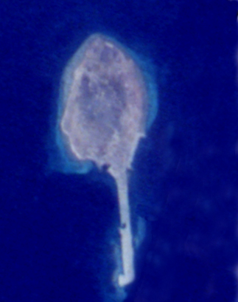
Satellite image of Dalma
ADIAS team visits Dalma
An ADIAS team visited Dalma island from 10-12 October 2004. Dr Mark Beech (ADIAS Senior Resident Archaeologist) and Karen Cooper (ADIAS Administrative Assistant) visited Dalma and met with Muhana Obaid Ghaith Al-Muhairi, Director of Dalma Municipality, as well as with contractors working for the Municipality on the island.
The purpose of this was to discuss and organise the fencing of a number of important archaeological sites located in Dalma town. These were the early and middle-Islamic period settlement and graveyard located inside a farm (site DA7), and the Islamic graveyard located just behind the Co-Op shopping mall in the town (site DA8).
Visits were also made to the important Ubaid-related settlement on Dalma (Sites DA11 and DA12). It was recommended that fencing be placed around site DA12, and that the compound where site DA11 is located be fully protected.
A report on this visit which includes recommendations for further actions has been submitted to the Abu Dhabi Municipality.

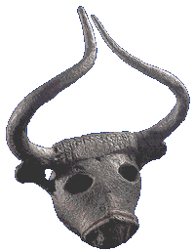
Bull’s head from the Danish excavations at Barbar, Early Dilmun c.2000-1800 BC

Dilmun Civilisation Celebration in Bahrain
Dr Mark Beech, our Senior Resident Archaeologist, will be participating in a three day festival in Bahrain from 27-30 November commemorating the 50th anniversary of the discovery by a Danish team in 1954 of the remains of the Dilmun civilisation.
The event coincides with the completion of a 17-year renovation project at the Bahrain Fort, which dates back to the Dilmun period.
Apart from presentations, speeches and entertainment, there will also be excursions to Bahrain's archaeological sites on November 28 at 4pm. Participants will also visit the Barbar Temple, Saar Settlement, A'ali burial mounds and the royal mounds in A'ali.
Archaeologists from Denmark will carry out further excavations at the A'Ali burial mounds and the royal burial mounds during the festival, while a new exhibition on “Discovering Dilmun: 50 years of Danish Investigations” about all 12 Danish expeditions to Bahrain since 1954 will be opened at the Bahrain National Museum. It has been prepared by the Moesgard Museum in Denmark.

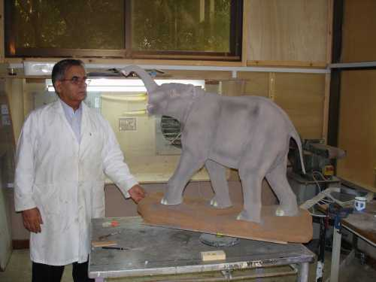
Abdul Hafeez stands by the model
of the Late Miocene elephant
Fossil Display
Our model of the Late Miocene elephant, Stegotetrabelodon syrticus, which was constructed in collaboration with Abdul Hafeez from the Private Department of H.H. Sheikh Zayed Bin Sultan Al Nahyan, has now been completed.
Work is now under way on completing the construction of the display case. The fossil display will be housed in the ERWDA headquarters, and is being sponsored by ADCO, Takreer and BP, with support from ERWDA and the Private Department.
It is planned that the inauguration of the display will take place around UAE National Day in early December.

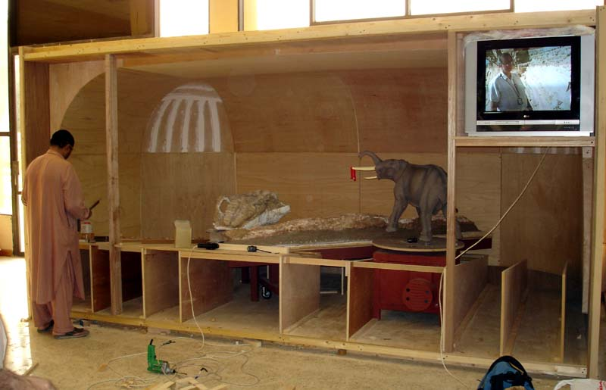
Building the showcase for the fossil display
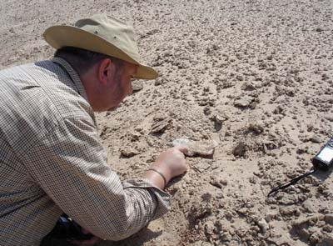
Dr Mark Beech discovers an almost complete equid (Hipparion) jaw with teeth at Ruwais

New fossil site discovered
at Ruwais

On October 12th an ADIAS team, comprised of Dr Mark Beech and Karen Cooper, made a brief visit to the Ruwais fossil site. A new fossil site was discovered by chance, adjacent to the area where the new BeAAT installation is being constructed.
A remarkable fossil specimen was discovered at the new locality (site RUW0065) at Ruwais. This was an almost complete jaw of the primitive three-toed equid known as Hipparion. The jaw still had almost all its teeth in place (see photo below). Other specimens collected from the same locality included fossils from crocodile, fish, turtle and elephant.
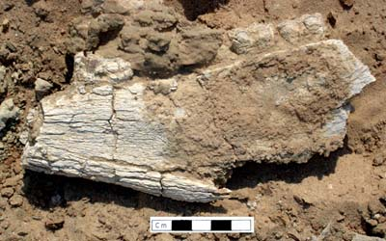
Close-up of the equid (Hipparion) jaw
Regular readers of the ADIAS Occasional Newsletter will recall the work carried out by ADIAS during the winter of 2002 and spring of 2003 when over 7000 fossil fragments were recovered from surface survey of an area being developed by Takreer at Ruwais. A number of astonishing fossil specimens were excavated during this previous work, including an almost complete 2.54 metre long tusk of the primitive elephant species, Stegotetrabelodon syrticus.
Other previously-unrecorded fossil sites were found in July by Simon Aspinall, Director of ADIAS Environmental Studies, close to the FERTIL and Borouge plants in the Ruwais industrial area. One, of particular interest, was close to the Borouge plant, and produced fossils from several mammal species.
This July work was carried out on behalf of GASCO, who are planning to develop their plant at Ruwais, and asked ADIAS to check the area for fossils. We are most grateful to GASCO for their support.
These fossil sites date back to the Late Miocene period, 6-8 million years ago. Fossils found on these sites include a wide range of material, including fish, crocodile, turtle, molluscs and mammals. Readers of the Newsletter will soon be able to see for themselves many of these important fossils when they go on display in Abu Dhabi this winter.

Shells and Archaeology
ADIAS is currently working on the preparation of a book entitled “Shells and Archaeology”. This work is rather appropriately being sponsored by the oil company Shell, through their Abu Dhabi office.
In early December, Emily Glover, a research associate from the Mollusc section at the Natural History Museum in London, will visit Abu Dhabi for 10 days to collaborate with Dr. Mark Beech on work on the project.
The book discusses the history and methods of research on marine mollusca in the Gulf region, the environmental history of the Gulf, and the human use of marine shells from prehistory to recent historical times.

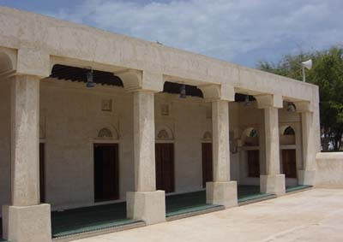
The al-Muhannadi mosque on Dalma island
Mosques of Abu Dhabi

Dr Geoffrey King (ADIAS Academic Director) is shortly due to arrive in Abu Dhabi. He will be working on material for a new book to be published by ADIAS in 2005 entitled “The Mosques of Abu Dhabi”. During his stay Dr. King will be visiting the ADCO photographic archives to collect more information for this project.
A summary of information about three important historic mosques on the island of Dalma in an article by Dr King will be published in the forthcoming issue of TRIBULUS, the Journal of the Emirates Natural History Group (for more details see below).

Lectures

Over the last few months, ADIAS team members have been active in giving lectures in Abu Dhabi.
Dr Mark Beech gave a briefing on underwater archaeology to divers involved in the Clean-Up Arabia event which was held at Mirfa on 17th September. The briefing took place in ERWDA Abu Dhabi, on the 15TH September.
Peter Hellyer lectured on the 5th October 2004 to the Emirates Natural History Group, entitled “An Introduction to the Tribes of Abu Dhabi”, in the Cultural Foundation.
On the 9th November, Dr Mark Beech will talk about the recent archaeological work carried out on Marawah island to the Al Ain branch of the Emirates Natural History Group. The lecture will be held in the Intercontinental Hotel in Al Ain starting at 8 p.m. All are welcome.

Forthcoming Publications

Two papers on ADIAS work are due to be published shortly.
The next issue of TRIBULUS, Volume 14.2, the bi-annual journal of the Emirates Natural History Group, will include a paper by Dr. Mark Beech and Nasser Al-Shaiba on the newly discovered ancient boat mooring sites on Marawah island. It also includes a paper by Dr. Geoffrey King, ADIAS Academic Director, on the al-Muhannadi, al-Muraykhi and al-Dawsari mosques on Dalma island, some of the UAE’s most important surviving buildings. Copies of TRIBULUS will be available from the ADIAS office.
Two ADIAS papers were presented this summer at the Seminar for Arabian Studies held at the British Museum from 22-24 July, 2004. For more details about the conference visit the following website:
www.arabianseminar.org.uk
The ADIAS papers presented at the conference were: “Kharimat Khor al-Manahil and Khor Al Manahil – New Neolithic sites in the south-eastern desert of the UAE”, by: H.Kallweit, M. Beech and W. Yasin Al-Tikriti; and “New evidence for the Neolithic Settlement of Marawah Island, Abu Dhabi, United Arab Emirates”, by: M. Beech, R. Cuttler, D. Moscrop, H. Kallweit and J. Martin.
Both these papers will be published in the “Proceedings of the Seminar for Arabian Studies, Volume 35” due to be published in June 2005. Copies of the Proceedings can be ordered from:
ArchaeoPress,
Gordon House, 276 Banbury Road,
Oxford OX2 7ED, U.K.
Tel/Fax:+44 (0)1865 311914
Email: bar@archaeopress.com
Web: www.archaeopress.com
--------------------------------------------
The ADIAS Occasional Newsletter is
edited by Dr. Mark Beech & Peter Hellyer.
-----------------------------------------

