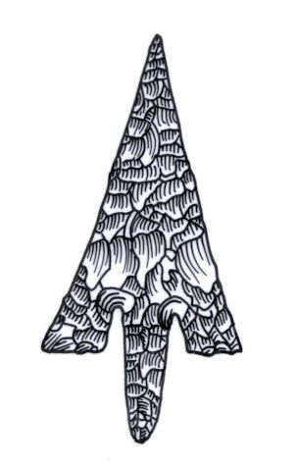
Th ADIAS Occasional Newsletter
November 2005 No. 1 – 2005-2006 Season

Abu Dhabi Islands Archaeological Survey (ADIAS)

Patron: HH Sheikh Mohammed bin Zayed Al Nahyan
P.O. Box 45553, Abu Dhabi, U.A.E.
Tel: +9712 6934515 – Fax: +9712 6810008
Email: adias@ead.ae
Web: www.adias-uae.com

ADIAS to become part of new Abu Dhabi
Culture and Heritage Authority

On 14th October, President HH Sheikh Khalifa bin Zayed Al Nahyan, acting as Ruler of Abu Dhabi, issued a law to establish the Abu Dhabi Culture and Heritage Authority.
Once the new Authority is operating, ADIAS will be absorbed into it, as part of a restructuring of the way in which archaeology and palaeontology are handled in the Emirate of Abu Dhabi.
For those that may have missed the local press stories, the following summary outlines the responsibilities of the new Authority.
According to the terms of the new Law, the Authority: "will oversee intellectual and artistic activities in the Emirate of Abu Dhabi and will also be responsible for maintaining, protecting, managing and promoting the cultural heritage of the Emirate through the following means:
- the evolving of cultural policies, plans and programmes and ensuring that such policies are implemented.
- undertaking projects designed to develop, promote and protect the cultural heritage of the Emirate and to make appropriate recommendations to the relevant authorities.
- organising and developing activities dealing with the heritage of the country as well as organising conferences, cultural shows, plastic arts exhibitions and other activities related to the activities of the National Library.
- organising study programmes and seminars and other intellectual, scientific and professional meetings in addition to the publication of research and studies in the field of culture and heritage.
- conserving historical, archaeological and heritage sites and buildings and preparing an inventory of cultural property and artefacts.
- carrying out of archaeological excavations, conserving archaeological artefacts and relics and issuing licences for excavations.
- supervising the work and activities of archaeological excavation teams and establishing a department to manage, develop and supervise museums and other buildings where cultural artefacts are housed.
- recommending laws and regulations to protect, promote and preserve cultural heritage.
- providing support for training and educational activities.
- developing human and cultural resources in the fields of documentation, management, archiving and preservation of cultural heritage.
- outlining general plans for the activities of museums, in addition to planning for exhibitions on heritage.
- checking for violations of and damage to the cultural heritage and antiquities of the emirate and taking the necessary legal action in association with the relevant authorities.
- providing support and assistance to bodies working in the field of the preservation, management and promotion of cultural heritage.
- exercising control over heritage and cultural property, whether public or private
- managing the National Library in such a way as to enrich and promote intellectual, artistic and scientific activities in Abu Dhabi through the provision of references, journals and periodicals in Arabic and other languages in various fields of knowledge.
- recording national history through the collection of documents, the registering of the heritage of the emirate and through the publication of works in this field.
The Authority will be governed by a Board of Directors, consisting of a Chairman, a Deputy Chairman and seven or more other members, whose powers will be specified in a decision to be taken by the Abu Dhabi Executive Council.
Also to be merged into the new Authority are the Cultural Foundation, the Department of Antiquities and Tourism in Abu Dhabi's Eastern Region and the Cultural Heritage section of the Abu Dhabi Tourism Authority.

ADIAS looks forward to joining and becoming part of this new agency.

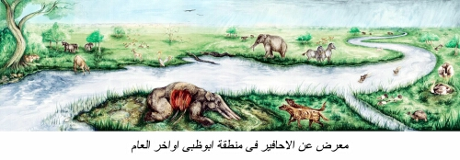
Official Inauguration of ADIAS Fossil Exhibition
The official inauguration of the exhibition “Abu Dhabi 8 Million Years Ago – Late Miocene Fossils from the Western Region” took place on 26th November 2005.
Housed in the headquarters of ADIAS and the Environment Agency - Abu Dhabi (EAD), the exhibition includes the remains of elephants, crocodiles, gazelles, turtles, horses and other animals that lived in Abu Dhabi during the Late Miocene period, around eight million years ago.
The display has been organised with support from the Abu Dhabi Company for Onshore Oil Operations, ADCO, Takreer and BP, and with technical help from the Taxidermy Unit of the Private Department of HH the President.

Majid Al-Mansouri, (Secretary-General from EAD), inaugurated the display, which is now open to the public.

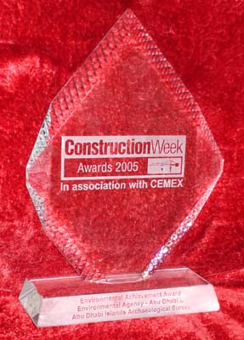
Environmental Achievement of the Year Award 2005
The Abu Dhabi Islands Archaeological Survey, ADIAS, was selected as joint winner, with the Environment Agency - Abu Dhabi, EAD, of the Environmental Achievement of the Year Award presented by the Gulf's leading construction industry journal, "Construction Week." The Award was presented at a ceremony at the Fairmont Hotel, Dubai, on 17th November, and covers the six member states of the Gulf Co-Operation Council, GCC, the United Arab Emirates, Oman, Qatar, Bahrain, Kuwait and Saudi Arabia.
The ADIAS Executive Director, Peter Hellyer, issued the following statement on receiving the Award.
"ADIAS is delighted to have been selected as joint winner of the Environmental Achievement of the Year Award for 2005, and to share this with the Environment Agency - Abu Dhabi, EAD, with whom we work very closely.
"Since it was established on the instructions of former UAE President Sheikh Zayed bin Sultan Al Nahyan in 1991, ADIAS has sought to work with industry and developers in the Emirate of Abu Dhabi, both government departments and the private sector, to ensure that the identification and preservation of archaeological and fossil sites is accepted as being part of the normal process of development. The Government sector, the oil industry and Abu Dhabi's new property developers have all responded extremely well to our approaches. As a result, ADIAS has been able to discover, and to examine and preserve, many sites of importance to the UAE's national heritage that would not otherwise have been recognised.
"In this process, we have worked very closely with EAD, and its predecessor, the Environmental Research and Wildlife Development Agency, ERWDA. The Agency has provided ADIAS with enormous support, ensuring that conservation of archaeology and fossils is given equal importance to the conservation of the environment and wildlife. Together, ADIAS and EAD will continue to ensure that these issues are given the full importance that they deserve as Abu Dhabi embarks on its major new programme of development.
"We are honoured to have been recognised by "Construction Week", the key Gulf journal for an industry with which we are keen to continue to collaborate closely in the future. The Government of Abu Dhabi is committed to achieving a sustainable balance between development and conservation, and we in ADIAS look forward to continuing to play our part in this process, as part of the new Abu Dhabi Culture and Heritage Agency."
ADIAS website hits

As a result of recent activities and publicity there has been a marked increase in the number of visitors to the ADIAS website. During October 2005 the site registered more than 162,127 hits from 29,331 unique visitors, an average of around 5,230 hits per day from 946 unique visitors. So far, three weeks into November, we have had 138,707 hits from 31,621 unique visitors, an average of around 6305 hits per day from 1437 unique visitors.

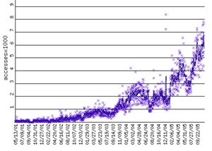

On the 15th November 2005 the website had a record number of visitors when there were 10,056 hits from 4,610 unique visitors!

The ADIAS webmaster is our Senior Resident Archaeologist, Dr. Mark Beech. Please send any comments or suggestions you have concerning the website to him at: adias@ead.ae
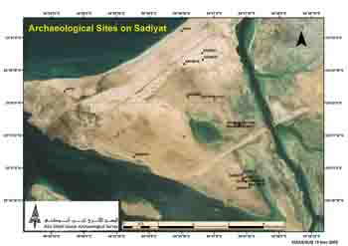
Satellite image of Sadiyat
marking archaeological sites

New archaeological
Work on Sadiyat
An initial archaeological survey of Sadiyat was carried out by ADIAS team member Dr Heiko Kallweit in June 2005. This identified a number of archaeological sites dating to the Late Islamic period in the north-east, central and south-eastern parts of the island.

In association with the Abu Dhabi Tourism Authority (ADTA), Dome Engineering and Parsons International, the project management consultants, an ADIAS team comprised of Dr. Mark Beech, Simon Aspinall and Suzan Al-Mutawa, visited Sadiyat on 20 November 2005. Visits were made to all the key archaeological sites on the island. A report was subsequently submitted to the relevant authority recommending that two key areas be fenced for their protection pending further archaeological work.

Work on Sadiyat will resume in late January 2006.

More archaeological
Work planned for Umm az-Zamul and Marawah
A third season of archaeological work at Umm az-Zamul is planned this winter. Work will commence on 28th December and will continue until around 23 January 2006.

The aims this season are to complete the pick up and mapping of lithics at Khor Al Manahil, as well as undertaking archaeological excavations of selected features. Further surveying of adjacent areas will be also carried out to develop our understanding of the landscape history of the region.

A team from the Department of Archaeology at the University of York is due to undertake geophysical survey on Marawah island during the second half of February 2006. Ground Penetrating Radar (GPR) will be used to survey the important Neolithic settlement site of MR11. This hopefully will shed light on the layout of the settlement and will help to inform future excavation strategies.
A second season of excavations is planned at site MR11 during March 2006. The aims this season will be to complete the excavation of the adjacent rooms of the main building first identified during the March 2004 season. Additional trenches will be made in other features at the site to test the preservation of structures.

Lectures

ADIAS team members have once again been active in giving lectures in Abu Dhabi.
On the 4th October, Dr Mark Beech, ADIAS Senior Resident Archaeologist, gave a lecture to the Abu Dhabi branch of the Emirates Natural History Group in Abu Dhabi, entitled “Elephants in the Desert - Abu Dhabi 8 Million Years Ago: The Story behind the Exhibition”. He talked about the history of work on Miocene fossils in Abu Dhabi including the more recent work carried in Ruwais and Mleisa.
On 20th November, ADIAS Executive Director Peter Hellyer spoke to a group of ladies from our sponsor, BP, about the archaeology and fossils of Abu Dhabi.
ADIAS to participate in
World Heritage Meeting
ADIAS will be participating in the important Regional Meeting, “World Heritage in the Arab States: Follow-up to Periodic Reporting and Information Management”, held under the patronage of Sheikh Sultan bin Tahnoun Al Nahyan, Chairman of the Abu Dhabi Tourism Authority, from 4 to 8 December 2005. The event is being held at Le Royal Meridien Hotel in Abu Dhabi. Wednesday 7 December will see the launch of the “Abu Dhabi Cultural Heritage Management Strategy”.
Review of ADIAS Publication
Professor Gerd Weisgerber has recently published a review of the ADIAS publication: ”Sulphur, Camels and Gunpowder - The Sulphur Mines at Jebel Dhanna, Abu Dhabi, United Arab Emirates - An archaeological site of the late Islamic period”. Edited by: G.R.D. King. 2003. Abu Dhabi Islands Archaeological Survey (ADIAS) and the Abu Dhabi Company for Onshore Oil Operations (ADCO), Abu Dhabi. ISBN 1-904566-43-X.
This is published in German in Der Anschnitt - Zeitschrift fur Kunst und Kultur im Bergbau (2005) 57 H2-3: pp.129-130.
The review said… “The authors give a detailed description of how and when gunpowder and cannons were introduced to the Arabian-Persian world and how the Portuguese, Dutch and British taught them their use. Sulphur - alongside charcoal and saltpetre was a main component of gunpowder. One needs to agree with the author that the hitherto unknown quantity of sulphur produced in Abu Dhabi was associated only with the production of gunpowder.
One is grateful to have such a mining rarity so pleasantly presented. That the English vocabulary for technical terms in mining rarely coincides with a rather detailed and specific German terminology, cannot be blamed on the authors.”

New Books
The following publications have been issued locally since the last ADIAS Occasional Newsletter.

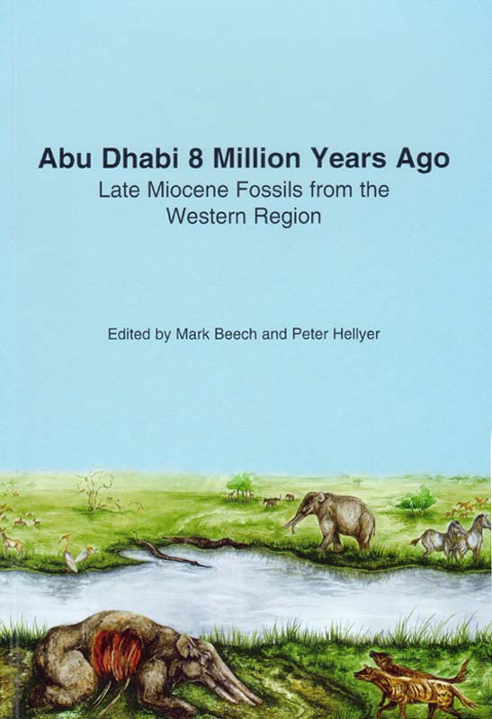

Abu Dhabi 8 Million Years Ago - Late Miocene Fossils from the Western Region. Edited by Mark Beech and Peter Hellyer. 2005. Abu Dhabi Islands Archaeological Survey (ADIAS), Abu Dhabi, UAE. 68 pages; 73 figures, maps, plans, drawings, photographs. ISBN 9948-03-188-1. Available in English. Price: 20 DH (equivalent to $ 5.50 USD).
The contents of the book are as follows:
Foreword by Sheikh Mohammed bin Zayed Al Nahyan, Crown Prince of Abu Dhabi and Patron, Abu Dhabi Islands Archaeological Survey (ADIAS);
Chapter 1 - The impact of archaeology on the palaeontology of the Western Region of Abu Dhabi: the History of Palaeontological Research by Walid Yasin Al-Tikriti (pages 10-13);
Chapter 2 - Miocene Geology and Fossils of Abu Dhabi by John R. Stewart (pages 14-20);
Chapter 3 - The Late Miocene fossil site at Ruwais by Mark Beech (pages 21-33);
Chapter 4 - Conservation of Late Miocene fossils from Abu Dhabi by Nigel Larkin (pages 34-36);
Chapter 5 -The Fossil Trackway at Mleisa by Will Higgs (pages 37-41);
Chapter 6 - Conclusion: the importance of Abu Dhabi's Late Miocene fossil sites by Mark Beech and Peter Hellyer (pages 42-43);
Appendix 1 - Catalogue of the Fossils in the Exhibition "Abu Dhabi 8 Million Years Ago - Fossils from the western Region" by Mark Beech (pages 43-55);
Appendix 2 - Constructing the scale model of Stegotetrabelodon syrticus by Abdul Hafeez, Izhar Hafeez and Mark Beech (pages 56-59);
Appendix 3 - The reconstruction painting "Abu Dhabi 8 Million Years Ago" by Gemma Goodall and Nigel Larkin (pages 60-62);
Appendix 4 - Details of the audio-visual presentations in the Exhibition, "Abu Dhabi 8 Million Years Ago - Fossils from the western Region" (pages 63-64);
Appendix 5 - List of Contributors (page 65);
Bibliography: Books, Websites & Scientific references (pages 66-68).

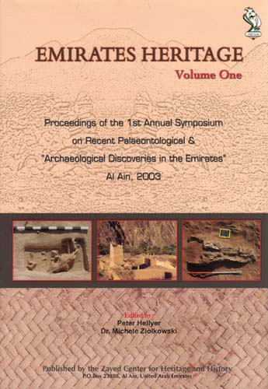
Emirates Heritage Vol. 1 - Proceedings of the 1st Annual Symposium on Recent Palaeontological and Archaeological Discoveries in the Emirates, Al Ain.
Edited by: Peter Hellyer and Michele Ziolkowski. 2005. Zayed Centre for Heritage and History, Al Ain. ISBN 9948-06-130-6. 139 pages.
This book, co-edited by the ADIAS Executive Director features two chapters by ADIAS staff.
Beech, M. and W. Higgs. A New Late Miocene Fossil Site in Ruwais, Western Region of Abu Dhabi, United Arab Emirates. Pages 5-20.

Higgs, W., A.Gardner and M. Beech. A Fossil Proboscidean trackway at Mleisa, Western Region of Abu Dhabi, United Arab Emirates. Pages 21-27.

Other New Publications
Other papers written by ADIAS staff which have recently been published include the following:
Beech, M., R. Cuttler, D. Moscrop, H. Kallweit and J. Martin. 2005. New evidence for the Neolithic settlement of Marawah island (Abu Dhabi, United Arab Emirates. Proceedings of the Seminar for Arabian Studies 35: 37-56.
Beech, M. and E. Glover. 2005. The environment and economy of an Ubaid-related settlement on Dalma island, United Arab Emirates. Paléorient 31/2: 101-111.
Carter, R.A. 2005. The History and Prehistory of Pearling in the Persian Gulf. Journal of the Economic and Social History of the Orient 48/2: 139-209.
Dennell, R.W., R. Coard, M. Beech, M. Anwar and A. Turner. 2005. Locality 642, An Upper Siwalik (Pinjor Stage) Fossil Accumulation in the Pabbi Hills, Pakistan. Journal of the Palaeontological Society of India 50(1): 83-92.
Hawker, R., D. Hull and O. Rouhani. 2005. Wind-towers and pearl fishing: architectural signals in the late nineteenth and early twentieth century Arabian Gulf. Antiquity 79 (No. 305 - Sept 2005): 625-635.
Kallweit, H., M. Beech and W.Y. Al-Tikriti. 2005. Kharimat Khor al-Manahil: New Neolithic sites in the south-eastern desert of the United Arab Emirates. Proceedings of the Seminar for Arabian Studies 35: 97-113.
Some of these articles are available to download from the ADIAS website at:
www.adias-uae.com/publications.html

--------------------------------------------
The ADIAS Occasional Newsletter is
edited by Dr. Mark Beech & Peter Hellyer.
-----------------------------------------

